With core java knowledge we can build standalone applications
Standalone applications
====================
The applications which are running on single machine are called as "Standalone
applications".
eg: Calculator, MS-word, notepad,....
If we want to develop web-applications then we need to go for "Advanced Java".
What are webapplications?
The application which provide service over the web/internet are called as
"WebApplications".

eg: gmail.com, facebook.com,ineuron.ai,telusko.com,.......
In java we can develop webapplications using the following technologies
a. JDBC
b. Servlet
c. JSP/Thymeleaf
JDBC(Java Database Connectivity)
For a Java Application(Normal java class or Servlet) if we want to
communicate with database, then we need to go for
JDBC.
eg: To get mails information from database
To get Astrology information from Database

Servlet
Whenever some processing logic is required then we need to go for Servlet.
Servler is meant for Processing logic/Buisness Logic.
eg: Verify user
Communicate with the data
Process end user data

JSP
Whenever presentation logic is required todisplay something to the end user then we need to go for jsp
Jsp stands for View Component
eg: display login page
display inbox page
display error page
display result page
JDBC
The current version of JDBC is 4.X(4.2V)
JDK s/w required => jdk8 and above
Steps given by SUNMS to communicate with Database
=============================================
1. Load and register the Driver.
2. Establish the connection with Database.
3. Create Statement Object and execute the Query.
4. Process the ResultSet.
5. Handle the SQLException if it gets generated.
6. Close the Connection.
1. Load and register the Driver
We need to load and register the Driver as per the DB requirement.
As per the DB specification, we need to set the JRE environment with
the DB environment.
Any class of DB vendor, we say at is Driverclass, iff it has
implemented a interface called "Driver".
MySQL =======> The implementation class of MySQLjar is "Driver".
2. Establish the Connection with database
public static Connection getConnection(String, java.util.Properties) throws
java.sql.SQLException;
public static Connection getConnection(String, String, String) throws
java.sql.SQLException;
public static Connection getConnection(String) throws java.sql.SQLException;
Connection connection = DriverManager.getConnection(url,username,password);
The above line would create connection Object,but Connection is an interface,can
object to interface be created?
Answer: No, for an interface instantiation is not possible.

In this line, an Object to a class which implements an interface called Connection is created and we hold the reference of the object with the interface name.
This is done to promote loose coupling in java.
The above code would also represent "abstraction".

3.Create Statement Object and execute the Query.
Statement statement = connection.createStatement();
The above line would create statement Object,but Statement is an interface,can
object to interface be created?
Answer: No, for an interface instantiation is not possible.
In this line, an Object to a class which implements an interface called Statement is created and we hold the reference of the object with the interface name.
This is done to promote loose coupling in java.
The above code would also represent "abstraction".
ResultSet resultSet =statement.executeQuery(sqlSelectQuery);
The above line would create statement Object,but ResultSet is an interface,can
object to interface be created?
Answer: No, for an interface instantiation is not possible.

In this line, an Object to a class which implements an interface

called ResultSet is created and we hold the
the reference of the object with the interface name.
This is done to promote loose coupling in java.
The above code would also represent "abstraction".

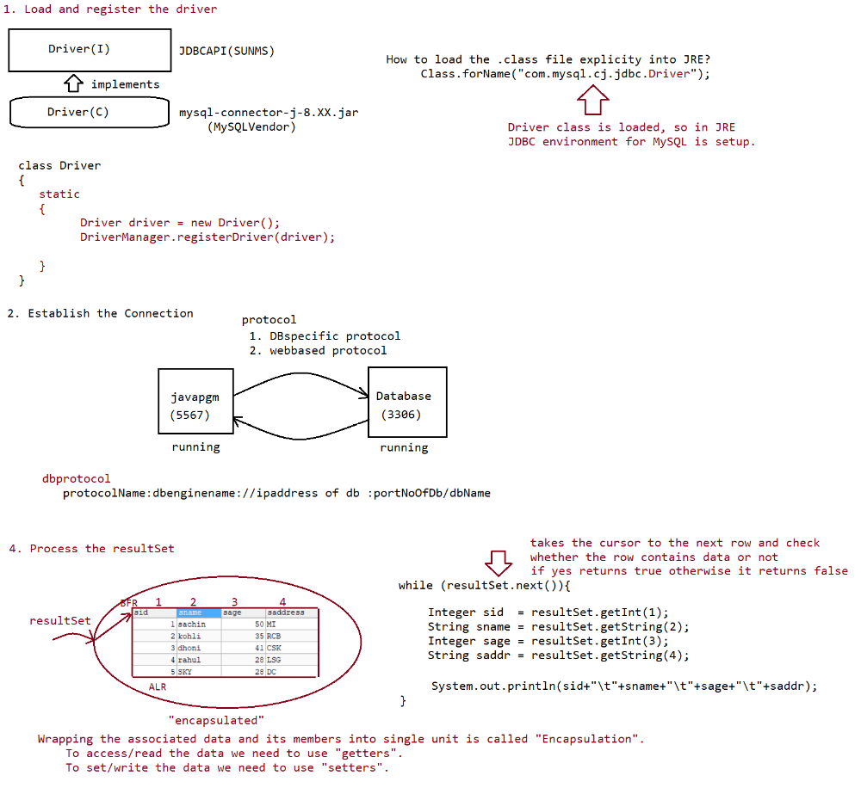
jdbc pgm to retrieve all records from database
======================================
import java.sql.*;
class TestApp {
public static void main(String[] args) {
Connection connection = null;
Statement statement = null;
ResultSet resultSet = null;
try{

//Step1. Load and register the Driver
Class.forName("com.mysql.cj.jdbc.Driver");
System.out.println("Driver loaded succesfully....");
//Step2. Establish the Connection with database
String url = "jdbc:mysql://localhost:3306/octbatch";
//username and password would vary from user to user
String userName = "root";
String passWord = "root123";
connection = DriverManager.getConnection(url,userName,passWord);
System.out.println("connection established succesfully...");
System.out.println("The implement class name is "+
connection.getClass().getName());
//Step3. Create statement Object and send the query
String sqlSelectQuery = "select sid,sname,sage,saddress from student";

statement = connection.createStatement();
System.out.println("The implementation class name
is ::"+statement.getClass().getName());
resultSet =statement.executeQuery(sqlSelectQuery);
System.out.println("The implementation class name
is ::"+resultSet.getClass().getName());
System.out.println();
System.out.println("SID\tSNAME\tSAGE\tSADDRESS");
//Step4. Process the resultSet
while (resultSet.next())
{
Integer sid = resultSet.getInt(1);
String sname = resultSet.getString(2);
Integer sage = resultSet.getInt(3);
String saddr = resultSet.getString(4);
System.out.println(sid+"\t"+sname+"\t"+sage+"\t"+saddr);
}
}catch (ClassNotFoundException ce){
ce.printStackTrace();
}catch(SQLException se){
se.printStackTrace();
}catch(Exception e){
e.printStackTrace();
}finally{
//closing the resources
if (connection!=null)
{
try
{
connection.close();
System.out.println("Connection closed...");
}
catch (SQLException se){

se.printStackTrace();
}
}
}
}
}
output
D:\jdbcoctbatch>echo %path%
C:\Program Files\Java\jdk1.8.0_202\bin
D:\jdbcoctbatch>echo %classpath%
;.;D:\jars\mysql-connector-j-8.0.31.jar
D:\jdbcoctbatch>javac TestApp.java
D:\jdbcoctbatch>java TestApp
Driver loaded succesfully....
connection established succesfully...
The implement class name is com.mysql.cj.jdbc.ConnectionImpl
The implementation class name is ::com.mysql.cj.jdbc.StatementImpl
The implementation class name is ::com.mysql.cj.jdbc.result.ResultSetImpl
SID SNAME SAGE SADDRESS
1 sachin 50 MI
2 kohli 35 RCB
3 dhoni 41 CSK
4 rahul 28 LSG
5 SKY 28 DC
Connection closed...

From JDBC4.X version onwards,there is a facility of "autoloading".
Q> What is autoloading in JDBC?
Loading and register the driver is done automatically,based on the url
supplied by the user.
Behind the scenes
a. check the url
b. based on the url supplied, go to classpath environmental variable
c. open the relevant jar
d. go to META-INF/services folder
e. open java.sql.Driver file
f. read the file and load the class supplied in the file

Note:
Using resultSet object, we can retrieve the records based on the column names
also.
If java pgm and database engine is running in the same program with the default
port no for database then
url can be of the following type

String url = "jdbc:mysql:///octbatch".
Program to demonstrate select operation using JDBC
==========================================
package in.ineuron.main;
import java.sql.Connection;
import java.sql.DriverManager;
import java.sql.ResultSet;
import java.sql.SQLException;
import java.sql.Statement;
//JDBC4.X autoloading feature is enabled.
public class SelectApp {
public static void main(String[] args) throws ClassNotFoundException,
SQLException {

// Step2. Establish the Connection
String url = "jdbc:mysql:///octbatch";
String user = "root";
String password = "root123";
Connection connection = DriverManager.getConnection(url, user,

password);

System.out.println("CONNECTION object created...");
// Step3. Create statement Object and send the Query
Statement statement = connection.createStatement();
System.out.println("STATEMENT object created...");
// Step4. Execute the Query and Process the resultSet
String sqlSelectQuery = "select sid,sname,sage,saddress from student";
ResultSet resultSet = statement.executeQuery(sqlSelectQuery);
System.out.println("RESULTSET object created...");
System.out.println("SID\tSNAME\tSAGE\tSADDRESS");
while (resultSet.next()) {
int sid = resultSet.getInt("sid");
String sname = resultSet.getString("sname");

int sage = resultSet.getInt("sage");
String saddress = resultSet.getString("saddress");
System.out.println(sid + "\t" + sname + "\t" + sage + "\t" +

saddress);
}
// Step6. Close the resources
resultSet.close();
statement.close();
connection.close();
System.out.println("Closing the resources...");
}
}
Output
Loading the driver...
CONNECTION object created...
STATEMENT object created...
RESULTSET object created...
SID SNAME SAGE SADDRESS
1 sachin 50 MI
2 kohli 35 RCB
3 dhoni 41 CSK
4 rahul 28 LSG
5 SKY 28 DC
Closing the resources...
Note
According to DBA specification, all SQL commands are categorised into following
types
a. DDL(Data Definition Language)
eg: Create table, alter table, drop table, etc...
b. DML(Data Manipulation Language)
eg: insert,update,delete
c. DQL(Data Query Language)
eg: Select
d. DCL(Data Control Language)
eg: Alter password, grant access,....
e. DA command(Database Administrator commands)
eg: start audit
stop audit

f. TCL(Transaction Control Language)
eg: commit, rollback,savepoint,....

According to Java Developer point of view, all SQL operations are classified into 2
types
a. Select operation(DQL)
b. Non-Select Operation(DML,DDL,...)
Through Statement Object we need to execute the Query and to exectue the Query we
need to make a call
to a method as shown below.
a. executeQuery()
b. executeUpdate()
c. execute()
a. executeQuery()
This method is used only if we perform select operation.

Because of this method execution, we will get a group of records which are
represented as "ResutlSet" object.

public ResultSet executeQuery(String sqlSelectQuery) throws

SQLException;

eg: ResultSet resultSet =statement.executeQuery("select

sid,sname,sage,saddress from student");
b. executeUpdate()
This method is used for "Non-Select Operations" like(Insert|Update|Delete)
Because of this method execution, we won't get group of records, we will get
a numeric value which represents
the number of rows affected. So return type of the method is "int".
public int executeUpdate(String sqlNonSelectQuery) throws

SQLException;

eg: int rowAffected = statement.executeUpdate("delete from

student where sid = 10");

System.out.println("No of rows affected is ::

"+rowAffected);
c. execute()

we can use this method for both select and nonselect operation
if we don't know the type of query at the begining and if is available

dynamically at the runtime then we need to use

this method for execution.
public boolean execute(String sql) throws SQLException;
eg: boolean value = statement.execute(dynamicQuery);
if(value == true)
{

//select Query
ResultSet resultSet = statement.getResultSet();
//process the resultSet

}
else
{

//nonSelect Query
int rowCount = statement.getUpdateCount();
System.out.println("Number of rows affected

is :: "+rowCount);
}

Formatting SQlQueries using dynamic input
===================================
1st approach
==========
sname = scanner.next();
sage =scanner.nextInt();
saddress = scanner.next();
String sqlInsertQuery = "insert into
student(`sname`,`sage`,`saddress`)values('"+sname+"',"+sage+",'"+saddress+"')";
2nd approach
===========
sname = scanner.next();
sage =scanner.nextInt();
saddress = scanner.next();
sname = "'"+sname+"'";
saddress = "'"+saddress+"'";

String sqlInsertQuery = "insert into
student(`sname`,`sage`,`saddress`)values("+sname+","+sage+","+saddress+")";
3rd approach
===========
The above 2 approaches are not recomended, to do formatting we prefer using
String class format() as shown below.

public static String format(String format, Object... args)

sname = scanner.next();
sage =scanner.nextInt();
saddress = scanner.next();
String sqlInsertQuery =String.format("insert into
student(`sname`,`sage`,`saddress`) values ('%s',%d,'%s')",

sname,sage,saddress);
Write a JDBC code to take dynamic input from the user to perform insert operation
package in.ineuron.main;
import java.sql.Connection;
import java.sql.DriverManager;
import java.sql.SQLException;
import java.sql.Statement;
import java.util.Scanner;
//JDBC4.X autoloading feature is enabled.
public class InsertApp {
public static void main(String[] args) throws SQLException {
// Step2. Establish the Connection
String url = "jdbc:mysql:///octbatch";
String user = "root";
String password = "root123";
Connection connection = DriverManager.getConnection(url, user,

password);

System.out.println("connection object created...");
// Step3. Create statement Object and send the Query
Statement statement = connection.createStatement();
System.out.println("statement object created...");
Scanner scanner = new Scanner(System.in);
System.out.print("Enter the name of the student :: ");
String sname = scanner.next();
System.out.print("Enter the age of the student :: ");
int sage = scanner.nextInt();
System.out.print("Enter the address of the student :: ");
String address = scanner.next();
System.out.print("Enter the gender of a student:: ");
String gender = scanner.next();
// Step4. Execute the Query and Process the resultSet
String sqlInsertQuery = String.format("insert into

student(`sname`,`sage`,`saddress`,`sgender`) values ('%s',%d,'%s','%s')",

sname, sage, address,gender);
System.out.println(sqlInsertQuery);
int rowAffected = statement.executeUpdate(sqlInsertQuery);
System.out.println("No of rows affected is :: " + rowAffected);
// Step6. Close the resources
statement.close();
connection.close();
scanner.close();
System.out.println("closing the resources...");
}
}
Output
connection object created...
statement object created...
Enter the name of the student :: mandana
Enter the age of the student :: 27
Enter the address of the student :: kodagu
Enter the gender of a student:: F
insert into student(`sname`,`sage`,`saddress`,`sgender`) values
('mandana',27,'kodagu','F')
No of rows affected is :: 1
closing the resources...
Note:
While writing JDBC code, the following steps are common

a. Establishing the connection
b. closing the resources
c. handling the exception
What would vary in every code is
a. query will be different
1. if it select process the ResultSet object.
2. if it non-select, process the integer value.
For the above 3 steps, the common util code is as shown below
package in.ineuron.util;
import java.sql.Connection;
import java.sql.DriverManager;
import java.sql.ResultSet;
import java.sql.SQLException;
import java.sql.Statement;
public class JdbcUtil {
private JdbcUtil() {
}
static {
//Step1: loading and register the Driver
try {
Class.forName("com.mysql.cj.jdbc.Driver");
} catch (ClassNotFoundException ce) {
ce.printStackTrace();

}
}
public static Connection getJdbcConnection() throws SQLException {
// Step2. Establish the Connection
String url = "jdbc:mysql:///octbatch";
String user = "root";
String password = "root123";
Connection connection = DriverManager.getConnection(url, user,

password);

System.out.println("connection object created...");
return connection;
}
public static void cleanUp(Connection con, Statement statement, ResultSet
resultSet) throws SQLException {

// Step6. Close the resources
if (con != null) {
con.close();
}
if (statement != null) {
statement.close();
}
if (resultSet != null) {
resultSet.close();
}
}
}
Note:
In the above code, the url pattern, username and password is hardcode.
These values would vary from user to user.
To set these values, we use properties file approach as shown below.
package in.ineuron.util;
import java.io.FileInputStream;
import java.io.IOException;
import java.sql.Connection;
import java.sql.DriverManager;
import java.sql.ResultSet;
import java.sql.SQLException;
import java.sql.Statement;
import java.util.Properties;
public class JdbcUtil {
private JdbcUtil() {
}
static {
// Step1: loading and register the Driver
try {
Class.forName("com.mysql.cj.jdbc.Driver");
} catch (ClassNotFoundException ce) {
ce.printStackTrace();
}
}

public static Connection getJdbcConnection() throws SQLException, IOException
{

// Take the data from properties file
FileInputStream fis = new FileInputStream("D:\\octbatchjdbcpgm\\

JDBCStandardApp\\application.properties");

Properties properties = new Properties();
properties.load(fis);
// Step2. Establish the Connection
Connection connection =

DriverManager.getConnection(properties.getProperty("url"),
properties.getProperty("username"),

properties.getProperty("password"));

System.out.println("connection object created...");
return connection;
}
public static void cleanUp(Connection con, Statement statement, ResultSet
resultSet) throws SQLException {

// Step6. Close the resources
if (con != null) {
con.close();
}
if (statement != null) {
statement.close();
}
if (resultSet != null) {
resultSet.close();
}
}
}
application.properties
==================
url=jdbc:mysql:///octbatch
username=root
password=root123

